# **CHAPTER 3**

# **DESIGN OF PROPOSED GENERATOR**

In previous chapters, background about wind energy conversion systems and detailed overview of the most used generator types are given. Then, challenges of modern wind turbine systems and fundamental equations are discussed. Then, direct drive axial flux permanent magnet generator is chosen for the design in this thesis study because of its lower mechanical losses due to eliminated gearbox, high torque per volume and axial length advantages thanks to selected AFPM topology. In this chapter, electrical and mechanical design parameters of axial flux permanent magnet generator will be described. To do this, analytical design equations of proposed generator are given in the following sub-sections. These design equations will be used in following chapters for genetic algorithm optimization and electromagnetic finite element analysis. Finally, a result comparison of electromagnetic FEA and analytical calculation for a sample 50 kW generator will be given to ensure the accuracy of the finite element analysis technique. Analytic design equations described in this chapter are coded in MATLAB and then used in genetic algorithm optimization, which will be discussed in the next chapter.

## Mechanical and Electrical Parameters

In previous chapter, it’s decided to use axial flux permanent magnet synchronous generator. In this machine, inner air-cored stator and outer rotor surface mounted permanent magnets will be used. General overview of proposed generator is given in Fig. 3-1. In this figure, three axially stacked generator blocks are given. However, this image includes only 4 poles of proposed system, for the sake of simplicity. There is a (3/4) ratio between pole pitch and coil pitch. Permanent magnets are shown with blue and red colors, showing the direction of magnetization. Concentrated windings are shown with green colors. C-shaped steel rotor cores are shown with gray colors.

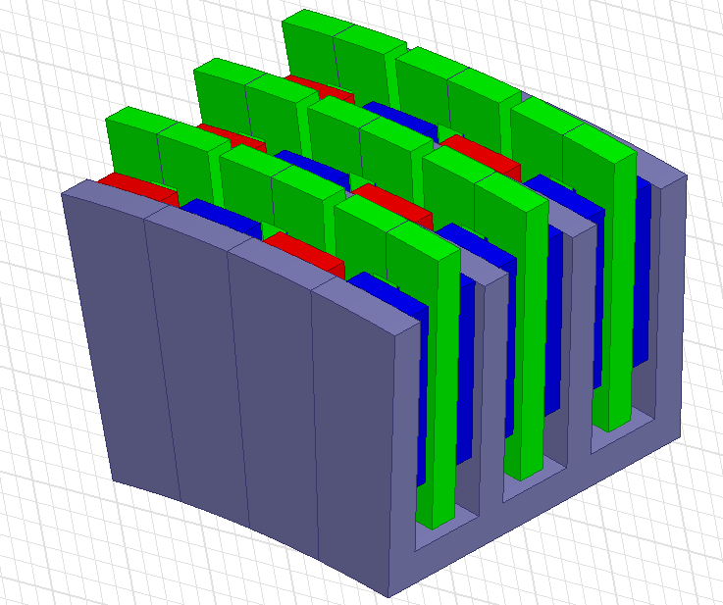

Fig. 3-1. Proposed AFPM generator

## Fundamental Equations

Per-phase equivalent circuit and phasor representation of synchronous machine is given Fig. 3-2 and Fig. 3-3, respectively. Output rms phase voltage (terminal voltage) of a typical synchronous machine is calculated as follows,

${ V}_{ph, rms}= E_{ph, rms}-I_{ph,rms}Z_{ph,rms}$ (3-1)

where, *Eph,rms*is the induced emf rms value, *Zph,rms* is the phase impedance under steady state temperature and $I_{ph,rms}$ is the rms phase current.

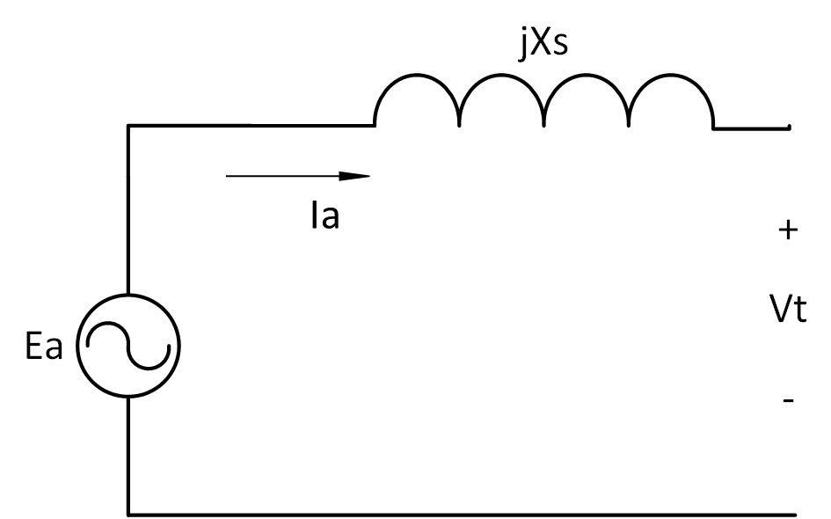

Fig. 3-2. Equivalent circuit of the synchronous machine where *Ea* is the induced emf, *Ia* is the phase current, *Xs* is the synchronous reactance and *Vt* is the phase terminal voltage[1]

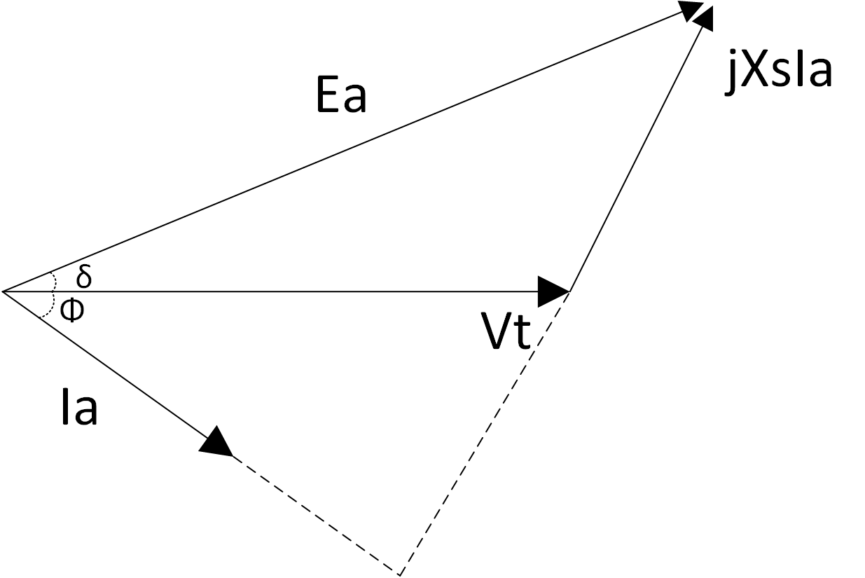

Fig. 3-3. Phasor diagram of synchronous machine where *δ* is the load angle, *Φ* is the power factor angle

*Eph,rms* is calculated as follow,

$E_{ph, rms}= E_{ph, peak}/√2$ (3-2)

$E_{ph, peak}=e*N_{t}*N_{s}$ (3-3)

Where *e* is the induced emf in one turn of conductor, *Nt* is the number of turns, *Ns* is the number of coils in series. Phase voltage peak and rms values according phasor diagram given in Fig. 3-3, are calculated as follows,

 (3-4)

 (3-5)

where  and  are phase resistance (which is relatively small than reactance) and phase reactance, respectively. Resistance and reactance calculations will be discussed in the following subsections. Power factor is assumed as unity in our design. Therefore power factor angle  is equal to zero. Load angle  is calculated at every rotation speed in the optimization design code according to trigonometric equation given below,

 in radian (3-6)

Induced emf *e* in one turn of coil is calculated as follows,

 (3-7)

where  is the peak flux linkage,  is the pole pitch and *v* is the airgap linear speed. Peak flux linkage is calculated for the proposed generator as follows,

 (3-8)

where  is the leakage coefficient, *ro* and *ri* are the outer and inner radius of rotor respectively,  and  are the outer and inner length ratios of the coil pitch and width of the winding, respectively, *Np* is the number of poles. Pole number *Np* is not a fixed value but evaluated during design optimization. Leakage coefficient  can be taken as constant of 0.95. Fundamental harmonic value of the air-gap flux density *Bag* is given as follows,

$B_{ag,1}=\frac{4}{π}*B_{ag}*\sin{(∝_{i}*(\frac{π}{2}))}$ (3-9)

where $∝_{i}$ is the magnet pitch-to-pole pitch ratio and $B_{ag}$ is the flux density in the airgap. Airgap linear speed *v* can be calculated as follows,

 (3-10)

where  is the mean radius and  is the mechanical speed in rad/s. Mean radius value will be determined according to optimization. Mechanical speed  is calculated as follows,

 (3-11)

where *n* is the rotational speed in rpm. Since proposed machine is a synchronous generator, frequency of the machine is defined as follows,

 (3-12)

## Geometrical parameters

Length ratios  and  used in Eq. (3-8) are calculated as follows,

 in radian (3-13)

 in radian (3-14)

 in radian (3-15)

where is the difference between two ratios.  and  are shown in Fig. 3-4. Pole pitch  value in Eq. (3-7) can be calculated as follows,

 (3-16)

Coil pitch  which is used in Eq. (3-13), can be calculated as follows,

 (3-17)

Ratio of (4/3) used in Eq. (3-17) is a natural result of the structure of the selected axial flux PMSG and will be used in related calculations as constant. Width of the winding value *tw* is calculated as follows,

 (3-18)

where  is the ratio of winding thickness to coil pitch. This parameters is determined in the optimization process. Outside radius *ro* and inner radius *r*i are given as follows,

 (3-19)

 (3-20)

where  is the mean airgap radius and *l*m is the axial length of the magnet. These two parameters are also evaluated in optimization algorithm in order to find suitable generator.

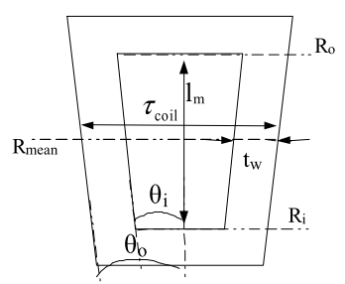

Fig. 3-4. C-core coil with inner and outer length ratios[2]

Magnet pitch-to-pole pitch ratio $∝_{i}$ is also referred as pole shoe arc-to-pole pitch ratio in [3] and can be described for our design as follows,

 (3-21)

This ratio can be taken as variable between 0.7 and 0.8. In our design this value is optimized with the help of the genetic algorithm. Lower values of this variable leads to lower utilization of permanent magnets, hence higher values are preferred. Steel-to-steel distance *lss* can be calculated as follows,

 (3-22)

where *hm* is the height of the magnet, *lmm* is the magnet-to-magnet distance. C-shaped core is given in Fig. 3-5 with related distances. Height of the magnet is determined during the optimization process. Magnet-to-magnet distance can be calculated as follows,

 (3-23)

where  is the height of the winding and *g* is the airgap clearance. Height of the winding is also determined during the optimization process.

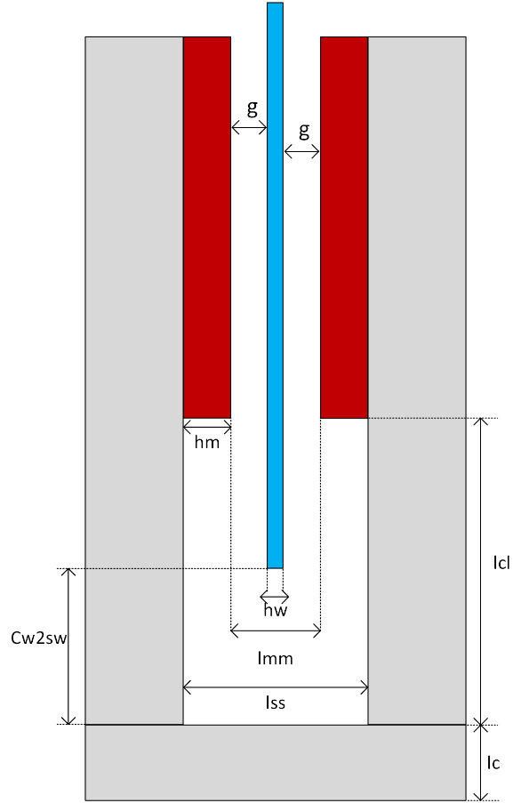

Fig 3-5. C-shaped core with defined distances. Gray: steel core, Red: Permanent magnets, Blue: stator windings

Steel web thickness *lc* is defined as the steel thickness at the bottom part of the C-shaped core and shown also in Fig. 3-5 and Fig. 3-6. Magnet-to-steel web clearance *lcl* is the distance between steel web and magnet bottom edge part, as shown in Fig. 3-5 and calculated as follows,

 (3-24)

where  is the distance between winding and steel web. This value is used in the optimization algorithm as a constant. However, selection of proper distance is important for design considerations. Groove distance is the clearance defined as the axial length in which the magnet buried in steel core limb. Since this value will be negligible small, groove distance can be taken as zero and it can be assumed that magnets are smoothly surface mounted on the C-cores without any gap. Circumferential distance between the C-cores, ie. inter-module clearance called as spacer gap (*c*) will be evaluated in the optimization part. However, spacer distance is also assumed as zero. Web pole pitch  is calculated as follows,

 (3-25)

where  is the steel web radius and calculated as follows,

 (3-26)

In Fig. 3-6, counter view of the one pole of the generator core limb diagram with different radius distances defined above is given.



Fig. 3-6. Counter view of one pole of the generator core limb with different radius values and pitches; *wm*: magnet width, : pole pitch, *lc*: steel web thickness

Magnet width distance *wm* can be calculated as follows,

 (3-27)

Stator outer diameter is important during the design because it should be limited for specific application and determines the main properties of a generator together with the parameter of axial length. Stator outer diameter is calculated as follows,

 (3-28)

## Structural Deflection

Structural deflection is related to mechanical stability. C cores try to close the airgap against each other and result in deflection in the air gap clearance. Main reason of this deflection is strong magnetic attraction forces between magnets in the airgap clearance. Ratio of this deflection with respect to airgap clearance is significant parameter in terms of structural modelling of the generator. It’s desired to keep this ratio below 10% in our design.

To model the structural deflection, beam model is employed. Normally C cores are exist on the web module. Therefore, length of the beam  is limited as sum of the magnet length  and magnet to steel web clearance. Right hand side of the beam is modelled as stationary wall to show the steel web part. Beam model is given in Fig. 3-7.



Fig. 3-7. a) Beam model for the C core deflection. b) Model for uniformly distributed load () is applied at *a=0* c) Model for uniformly distributed load () is applied at limited *a* units along the beam.

Normal stress *q* due to airgap flux density is calculated as follows,

 (3-29)

Uniformly distributed load  is calculated as follows,

 (3-30)

Total deflection *y* is calculated by summing the two sub-models as shown in Fig. 3-7. First sub-model demonstrates the deflection *y1* when a=0 and the second one demonstrates the deflection *y2* when *a*=. As mentioned before, beam length is calculated as follows,

 (3-31)

Two beam deflections (*y1* and *y2*) and resulting total deflection *y* are calculated as follows,

 for  (3-32)

 for  (3-33)

 (3-34)

where *E* and *I* are the Young’s Modulus of steel and the second moment of inertia of steel cross-section, respectively. Young’s Modulus is taken as constant as 200x109 Pa for structural steel. Second moment of inertia is calculated as follows,

 (3-35)

Ratio of deflection with respect to airgap, which shouldn’t be exceed 10%, is calculated as follows,

 (3-36)

## Phase turns, phase resistance & inductance and flux densities

Peak and rms values of the total current per phase can be calculated as follows,

 (3-37)

 (3-38)

where  and  are peak and rms values of the phase current, respectively.  is the current in one coil branch,  is the number of parallel coils.  value is calculated as follows,

 (3-39)

where *J* is the current density and  is the cross-sectional area of the conductor. Current density value can be selected before the design process as a constant. However, this value is optimized in our design according to operating conditions. More detailed information about this process can be found in next chapter. Cross-sectional area of the conductor, namely  can be calculated as follows,

 (3-40)

In this equation  is stand for the effective window area of the conductors and calculated as follows,

 (3-41)

where *kfill* is the fill factor for the winding coils. Fill factor can be taken as constant between 0.7 and 0.8 during optimization process due to concentrated air cored windings in our design. Conductor diameter *dcond* is calculated based of conductor area value as given below,

 in mm (3-42)

Resistance of one coil is calculated as follows,

 (3-43)

where  is resistivity coefficient of copper conductor, *lt* is the mean turn length for a coil and calculated as given in Eq. (3-44).

 (3-44)

where  ,  and  are defined for end part, middle part and structural part of the coil, respectively. These lengths are calculated as follows,

 (3-45)

 (3-46)

 (3-47)

Resistance per phase value is based on resistance per coil branch and calculated as follows,

 (3-48)

Resistance value given in Eq. (3-48) was calculated without thermal effects. Resistance value including thermal effects can be calculated as follows.

 (3-49)

where  is the temperature coefficient of copper and  is the temperature difference between ambient and expected operating temperature. Phase reactance  value is calculated as follows,

 (3-50)

where  is the angular frequency,  is the inductance of a coil. Angular frequency and inductance of a coil are calculated as follows,

 in radian (3-51)

 (3-52)

where  is the flux linked by coil. Inductance coefficient  can be taken as 1 during the design. Flux linked by the coil can be calculated as follows,

 (3-53)

Phase impedence *Zph* can be calculated using phase resistance and reactance values as follows,

 (3-54)

## Thermal Considerations

Cooling of the machine is chosen as forced air cooling. Therefore, we can determine a proper current density value at 100o C operating temperature. Then, calculation of the temperature rise for windings  can be calculated as follows,

 (3-55)

Resulting operating temperature can be found by summing the temperature rise value given above and ambient temperature, which can be assumed as 20o C. In the optimization process, operating temperature value is calculated at every different operating speed and respective current density values. Other constant and reference values will be explained in the next chapter.

## Reluctances

In order to find essential fluxes and flux densities of proposed generator, flux paths and reluctance network should be defined first. It’s assumed that leakage flux exists in the generator in order to calculate and analyze the generator more accurately. Therefore, flux paths and equations will be defined accordingly. Reluctances and flux paths are shown in side and top view of the cores in Fig. 3-8 and Fig. 3-9, respectively.

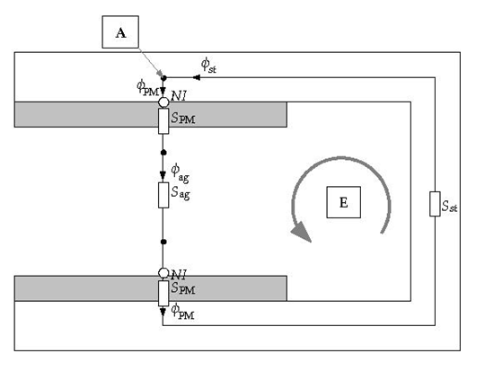

Fig. 3-8. Side view of the C-core for reluctances and flux paths

Airgap reluctance  of the machine is calculated as follows,

 (3-56)

where  is the permeability of air. Steel reluctance  can be evaluated as two parts, namely Part A and Part E, as given in Fig. 3-8. These specific reluctances and resulting total steel reluctance are calculated as follows,

 (3-57)

 (3-58)

 (3-59)

where  and  are thickness of outer limb and permeability of steel, respectively. Outer () and inner () limb thickness values are determined according to optimization process, which will be described in the next chapter. Reluctance of spacer is calculated as follows,

 (3-60)

where *c* is the spacer gap distance between modules. However, this gap between modules can be omitted. Because it’s negligible small in reality. PM reluctance consists of two parts: magnet itself reluctance and reluctance exist on the steel region. PM reluctance *SPM* is calculated as follows,

 (3-61)

where  is the permeability of the permanent magnet material. All the permeability values of different material of generator will be taken as constant during the optimization process.

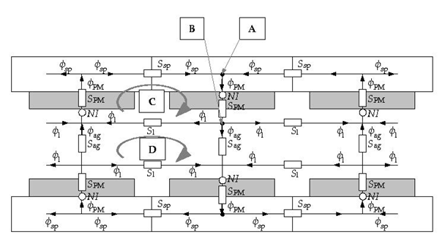

Fig. 3-9. Top view of the C-cores for reluctances and flux paths included leakage effect

Leakage path reluctance *S1* has two components. These components and resulting reluctance *S1* are calculated as follows,

 (3-62)

 (3-63)

 (3-64)

As can be seen on Fig. 3-8 and Fig. 3-9, permanent magnets are MMF source for the magnetic equivalent circuit. This MMF value provided by the permanent magnets, can be calculated as follows,

 (3-65)

where  is the remanent flux density of the permanent magnet. Remanent flux density value is taken as 1.4 T for the selected grade N50 rare-earth magnet.

## Flux and flux densities

In order to define fluxes and flux densities, magnetic circuit should be analysed in terms of reluctance network by using Kirchoff’s voltage and current laws. Therefore, node equations at point A in Fig. 3-8 and Fig. 3-9 can be written as follows,

 (3-66)

Equation at node B in Fig. 3-8 and Fig. 3-9,

 (3-67)

For the loop C,

 (3-68)

For the loop D,

 (3-69)

For the loop E,

 (3-70)

To obtain the required flux values, inverse of the reluctance matrix should be multiplied with the MMF matrix. These derivations are given as follows,

from Eq. (3-67) and Eq. (3-69) ,

 (3-71)

 (3-72)

From Eq. (3-66) ,

 (3-73)

 (3-74)

From Eq. (3-68) ,

 (3-75)

From Eq. (3-70) ,

 (3-76)

where, , ,  and  are spacer flux, steel flux, permanent magnet flux and airgap flux, respectively. If we combine these two MMF equations given in Eq. (3-75) and Eq. (3-76) ,

 (3-77) To solve this matrix problem left hand side of the equation should be multiplied by the inverse of the reluctance matrix *R*, which exists on the right hand side. Therefore resulting flux values are calculated as follows,

 (3-78)

Steel flux  is calculated according to Eq. (3-74). Flux densities are calculated based on above flux equations as follows,

For air-gap flux density,

 (3-79)

For spacer flux density,

 (3-80)

For steel flux density,

 (3-81)

## Volume and mass Equations

Total mass of the generator consists of two main categories. These are :

* Active mass
* Steel mass
* Copper mass
* Permanent magnet mass
* Structural mass
* Shaft
* Stator cylinder structure
* Rotor torque structure
* Steel band
* Epoxy

Active mass includes the materials which affect the electromagnetic performance of the machine directly while structural mass components generally provided mechanical stability to generator via non-magnetic materials.

## Active mass calculation

Total steel mass  consists of three main parts: outer limb mass, inner limb mass and web mass. These mass values are calculated as follows,

 (3-82)

where , , , ,  and  are mass of outer limb, number of outer limbs in machine, mass of inner limb, number of inner limbs in machine, mass of steel web and number of steel web part in machine, respectively. Mass of each components are calculated as follows,

 (3-83)

 (3-84)

 (3-85)

where  and  are mass density of the steel and height of steel web, respectively. Height of the steel web can be calculated as follows,

 (3-86)

Until now, mass components of the steel material have been calculated. However, these values are valid for only single layer. In order to include number of parallel machines into calculation, number of layers of each component should be multiplied with related single layer mass of component as given in Eq. (3-82). A sample view of 3-stage (number of parallel machine is three) axially stacked generator is given in Fig. 3-10. As it can be seen on this figure, number of outer limbs is always two regardless of the stack number of generators. Number of inner limb is always one less than that of the stack number. Number of steel web is same as number of stacks. Number of permanent magnets  is always double that of the stack number.



Fig. 3-10. Proposed axial flux PM generator side view with three axial stacks[2]

Total magnet mass  is calculated as follows,

 (3-87)

where  and  are mass density of permanent magnet material and total number of permanent magnet layers in generator, respectively. Total copper mass is calculated as follows,

 (3-88)

where  and  are mass density of copper and number of parallel stacks in the generator, respectively.

## Structural mass calculation

Total structural mass of the generator can be defined as the sum of the shaft mass, stator torque structure mass, rotor torque structure mass, steel band mass and epoxy resin mass.

Shaft can be modelled as a hollow cylinder. Therefore total shaft mass can be calculated as follows,

 (3-89)

where  ,  and  are shaft outer radius, shaft inner radius and shaft length, respectively. Shaft cylinder inner and outer radius values are used as constant in the optimization process. For the convenience, shaft length is selected as the 5/4 times that of the machine total axial length. Total axial length of the machine () is calculated as follows,

 (3-90)

 (3-91)

Total stator mass consist of a stator cylinder mass  and two times of the stator torque arm structure mass  . Formula of this mass is given as follows,

 (3-92)

Stator cylinder provides supportive mechanism to the stator windings and mass of this structure  can be calculated as follows,

 (3-93)

Stator torque structure holds the stator cylinder mechanism stable and consists of torque arms. These arms are formed of rectangle steel hollow bars as can be seen on Fig. 3-11. Stator torque arm structure mass is calculated as follows,

 (3-94)

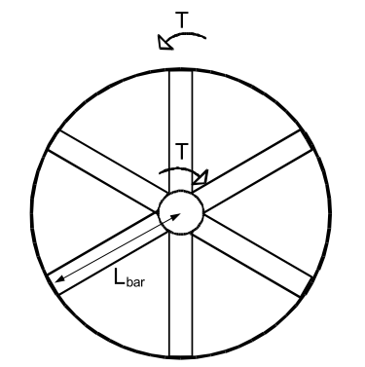

Fig. 3-11. Torque arm structure with 6 arms[2]

where  and  are the number of stator torque arms in a single structure and length of stator torque arms, respectively. Length of bar is generally half of the stator outer diameter of the machine. *b, d, bi,* and *di* are the cross-sectional distances of steel hollow bars. Constants used in the calculations of these values should be suitable in terms of hollow bar view and have very low effect on resulting mass. These lengths are shown in Fig. 3-12 and can be calculated as follows,



Fig. 3-12. Top view of steel hollow bar dimensions

 (3-95)

 (3-96)

 (3-97)

 (3-98)

Duty of rotor torque arms is to maintain stability to C-shaped cores of rotor. Total mass of rotor torque arms () is calculated in a very similar way that of stator torque arm calculation:

 (3-99)

where  and  are number of rotor torque arms and length of the rotor torque arm, respectively. Calculations and definitions for steel hollow torque arms for rotor are same as stator torque arm calculations. Therefore, Fig. 3-11 and Fig. 3-12 are valid for rotor torque arm structure. Length of rotor torque arm bar is equal to web radius . It can be optional to use supporting steel discs instead of rotor torque arms as shown in Fig. 3-10. However, torque arm is selected for rotor support in our design due to its simple design equations. In our proposed design 8 rotor bars and 6 stator bars is used.

Function of the steel band is to give mechanical support to coils and fix them to the stator structure. A sample steel band used in proposed generator is given in Fig. 3-13. Total steel band mass is calculated as follows,

 (3-100)

where  and  are the height and width of the steel band, respectively. These sizing values of the steel band can be determined during optimization.

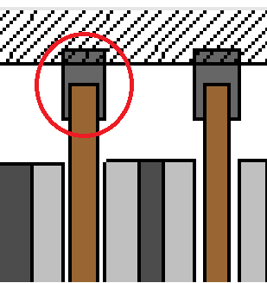

Fig. 3-13. Steel band

Epoxy resin is used to fill the free space around coils and to give mechanical support and insulation for winding[4]. Its total mass  in our proposed design is calculated as follows,

 (3-101)

where  and  are the mass density of epoxy resin and pitch of the coil former. Main duty of the coil former is the give mechanical support to the coils from inner side[4]. Representation of sample trapezoidal winding with distances including the pitch of the coil former is given in Fig. 3- 14. A commercial coil former which has open slots structure, is given in [6]. Mean pitch of the coil former  can be calculated as follows,

 (3-102)

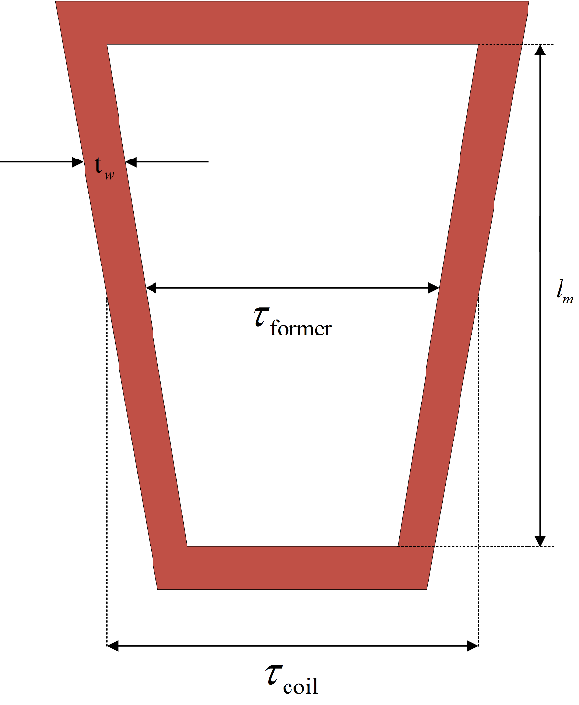

Fig. 3-14. Trapezoidal winding distances

## Losses

Total energy loss in the generator is sum of the core losses and the copper losses.

 (3-103)

Copper losses  are calculated as follows,

 (3-104)

Core losses  consist of eddy losses both on coils and magnet surface. These losses are calculated as given below,

 (3-105)

 (3-106)

 (3-107)

where ,  are coil and magnet components of eddy current losses, respectively.  and  are thickness and height of the copper conductor, respectively. *Bag* is the airgap flux density, *keddy* is the eddy loss coefficient used in calculating magnet surface eddy loss, *Nc* is the number of coils. Eddy loss coefficient is taken as constant of 57.65 W/m2 for rated speed(12 rpm) and it will be changed during the optimization according to operating frequency of generator. These variables are calculated as follows,

 (3-108)

Number of coils per phase (*Nc,ph*) is calculated by dividing *Nc* value by 3. Number of coils in series (*Ns*) is calculated as follows,

 (3-109)

Thickness and height of the copper values are calculated as follows,

 (3-110)

 (3-111)

In the equations above, ,  and  are height of the coil, thickness of the coil and thickness of the insulation material, respectively. Thickness of insulation is controlled during the design optimization. Height and thickness of the coil can be calculated as follows,

 (3-112)

 (3-113)

where  and  are thickness of epoxy and number of turns per strand, respectively. Epoxy thickness value can be taken as constant (1 mm) during the design process. Number of turns per strand value is calculated as follows,

 (3-114)

where  is the number of strand and taken as 1 in our design. Coil area including the insulation part is calculated as follows,

 (3-115)

Insulation area per coil  and insulation thickness  are calculated based on the coil area as given below,

 (3-116)

 (3-117)

## Power and Efficiency

Total output electrical power of the generator is given as follows,

 (3-118)

Efficiency of the generator is calculated as follows,

 (3-119)

## Electromagnetic FEA vs analytical evaluation for sample dimensions

In electrical machine design, airgap magnetic flux density is a key parameter to estimate. Because the airgap magnetic flux density affects the induced emf on stator windings via airgap flux calculations. Besides, airgap flux affects the core magnetic saturation characteristics. Hence core dimensions should be determined properly for normal flux distributions among the machine structure. Due to the reasons aforementioned above, it’s important to calculate the airgap flux density parameter correctly before machine production. Finite element modelling and analysis techniques are preferred especially when the machine geometry is hard to model and calculate analytically. In this subsection, some of the machine analytic equations described earlier in this chapter and the finite element modelling results will be compared in order to verify the design equations and techniques used in this thesis. Finite element modelling results are obtained from Ansys Maxwell 3D FEA analysis software.

To verify the design equations and techniques used in this study, airgap flux density and induced emf per phase values are chosen for the comparison. For this purpose, a 50 kW sample generator design is considered and evaluated in the optimization problem. Detailed information about optimization parameters and optimization process will be given in the next chapter. However, essential design parameters of the 50kW sample generator, which are achieved by the genetic algorithm optimization, are given in the Table 3-1.

Table 3-1. Optimized design parameters of the sample 50 kW generator

|  |  |
| --- | --- |
| **Parameter** | **Value** |
| Voltage per phase ${ (V}_{ph, rms})$ | 977.2 V |
| Induced emf per phase rms (*Eph,rms*) | 1058.1 V |
| Induced emf per phase peak ($E_{ph, peak}$) | 1496.4 V |
| Number of turns (*Nt*) | 146 |
| Number of poles (*Np*) | 96 |
| Output power (-per stack) | 15,396 W |
| Phase current ($I_{ph,rms}$) | 5.3 A |
| Phase resistance () | 14.92 Ω |
| Mean radius () | 0.7 m |
| Airgap clearance (*g*) | 2 mm |
| Rotational speed () | 60 rpm |
| Current density (*J*) | 4.03 A/mm2 |
| Outer limb thickness () | 15 mm |
| Inner limb thickness () | 14 mm |
| Steel web clearance (*lc*) | 16 mm |
| Fundamental airgap flux density peak value ($B_{ag,1}$) | 0.671 T |
| Height of the winding () | 13 mm |
| Winding thickness/Coil pitch ratio  () | 0.369 |
| Fill factor (*kfill*) | 0.65 |
| Height of the magnet (*hm*) | 10 mm |
| Length of the magnet (*l*m) | 87 mm |
| Magnet pitch-to-pole pitch ratio ($∝_{i}$) | 0.76 |
| Number of parallel branches () | 1 |
| Number of parallel machines () | 3 |
| Efficiency () | 92.38 % |
| Total mass (active + structural) | 1024 kg |

Peak value of the fundamental harmonic of the airgap flux density $B_{ag,1}$ is calculated according to Eq. (3-9). As it can be seen on the Table (3-1), this value is calculated as 0.67 T in our optimization process by using genetic algorithms. In the finite element analysis side, this peak flux density value is found as 0.65 T. For simplicity of the analysis 4 pole symmetric model is used in the analysis. Airgap flux density vector variation is recorded along the line which is shown in Fig. 3-15. This sinusoidal variation is shown in Fig. 3-16. As can be seen from the figures, peak value of the flux density is 0.65 T. Therefore it can be said that analytic equation results and finite element analysis results show good agreement in terms of airgap flux density.

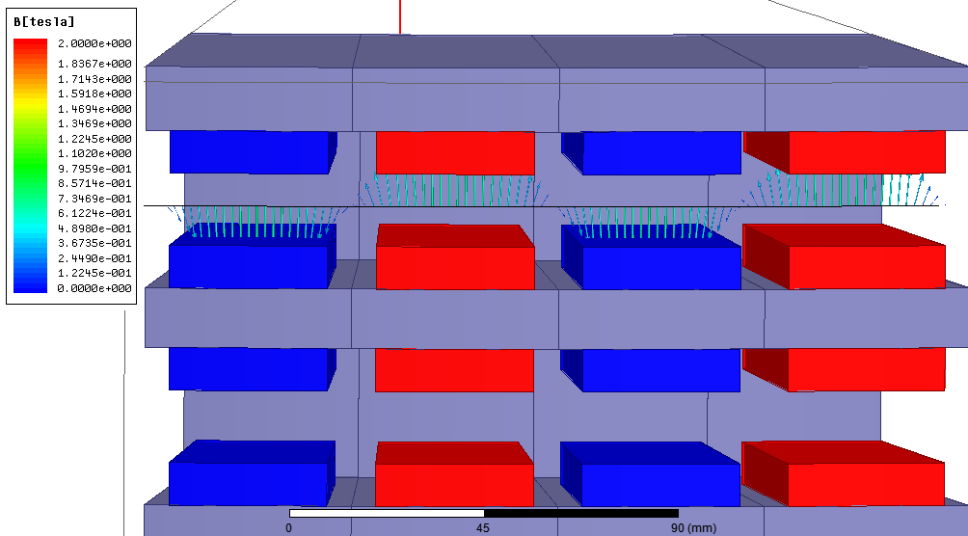

Fig. 3-15. Airgap flux density vectors for the sample 50 kW design



Fig. 3-16. Airgap flux density graph for the sample 50 kW design

Sinusoidal flux density variation induces sinusoidal voltages on windings. In our analytical design equations, induced emf (peak) per phase is calculated via Eq. (3-2) – Eq. (3-7) . As it can be seen on Table (3-1) this value is calculated as 1496.4 V. Induced emf per phase peak value of the finite element analysis is given in Fig. 3-17. This graph is obtained for three phase at rated speed of 60 rpm. All three phases are balanced(120o phase difference) in time domain and they all have peak magnitude of nearly 1600 V. Therefore it can be said that analytic equation results and finite element analysis results show good agreement in terms of induced emf.



Fig. 3-17. Induced emf per phase graph for the sample 50 kW design

## Conclusion

In this chapter, analytical design equations of the proposed AFPM generator are described. For this purpose, chapter is divided into two main sections. In the first section mechanical and electrical parameters of the proposed generator are covered with related graphics and mathematical expressions. These design equations are mainly consist of ; fundamental generator equations, geometrical and structural equations, phase turns, resistance and flux density equations, thermal equations, reluctance network and related equations, volume and mass equations and finally power and efficiency calculations. During the design of the proposed generator leakage fluxes are taken into consideration. Unity power factor is assumed for the phasor equations. These design equations are very important as their results will be used in the optimization process and finite element design. In the second section of the chapter, comparison of the results of the design equations and the finite element analysis is given for a sample 50 kW AFPM generator in order to verify the design method followed in this thesis study. For this purpose, airgap flux density and induced emf per phase parameters are chosen since they’ve been used widely in the design of electrical machines as key parameters [1]. It is concluded that the results of the analytical equations and the results of the finite element analysis are in good agreement. Therefore, these analytical equations can be used in the optimization for the proposed AFPM generator.

**References**

[1] B. S. Guru and H. R. Hiziroglu, “Electric Machinery and Transformers,” *Oxford Univ. Press*, p. 741, 2001.

[2] O. Keysan, A. S. McDonald, and M. Mueller, “Integrated Design and Optimization of a Direct Drive Axial Flux Permanent Magnet Generator for a Tidal Turbine,” in *International Conference on Renewable Energies and Power Quality - ICREPQ’10*, 2010.

[3] J. F. Gieras and M. Wing, *Permanent Magnet Motor Technology: design and applications*, vol. 113. 2002.

[4] J. F. Gieras, R.-J. Wang, and M. J. Kamper, *Axial Flux Permanent Magnet Brushless Machines*, vol. 3 ed. Dordrecht: Springer Netherlands, 2008.